**CS 3260**

**C# .NET Software Development**

**Lab #05**

**Version 1.0**



**Objectives:**

Your **Lab #04** should now be modified (refactored) with the following additions and/or modifications.

It should have, a ***BusinessRules*** class with a composite object (has-a relationship), this is an array of four (4) references to Employee objects. You need to add and an associated indexer that provides for adding and retrieving Employee object references to this array. Now replace this fixed size array with an “***Singleton***” object of a dynamic array (***DArray***) class, this MUST be a class of your own design and not a C# Collection class, DArray will dynamically resize, as the number of Employee references when it exceeds four (4) employee references or the current capacity of the array. It resizes by doubling its size and copying the student references to the new enlarged array, then making the new enlarged array the current array and garbage collecting the old array. It will continue to resize as needed. It must provide an indexer to allow the ability to get and set values in the ***DArray***. Your DArray class design MUST provide an elegant, efficient and error-free implementation. See the UML diagram in Fig. 1 and you must use this diagram to get started. You may add any members that you determine that are needed.

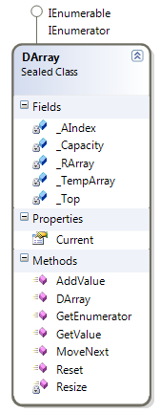

Figure 1 DArray Dynamic Array Class

|  |  |
| --- | --- |
| **Description** | **Points possible** |
| Assignment meets Grading Guidelines:  o Source code contains a Project Prolog with a declaration that you did not copy any code, except that provided.  o Assignment has been properly submitted to Canvas  o Code meets Style Guidelines.  o Code contains the required Project and method Prolog’s. |  |
| o Lab meets all of the specifications for this lab. |  |
| o Lab is elegant, efficient and works absolutely error free. |  |
| Total | 10 |

Submit with your UML diagram(s) by zipping with your Project folder properly renamed i.e. Lab_05_DAF_V1.0 .zip for me. Submit this file to [Canvas.](mailto:3260dennis@gmail.com)